Elders in Teams
To find out quickly whether you are on an up and coming Rota, simply click on the rota from the dashboard. Note that on the example the rotas are in the centre of the page but that may be different on your screen due to the different dashboard layouts available for you to choose from.
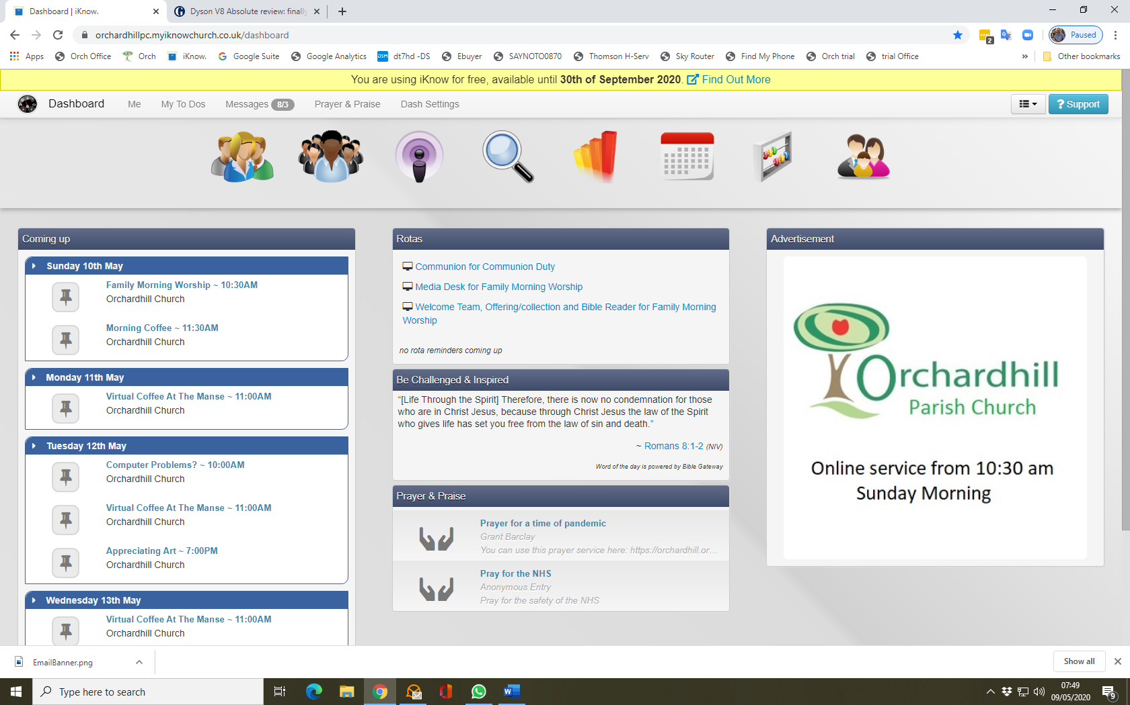

This will take you to a view screen of people listed in the up and coming rotas in the category you selected. You can select the date range you want generate that view and download a pdf with the rota.
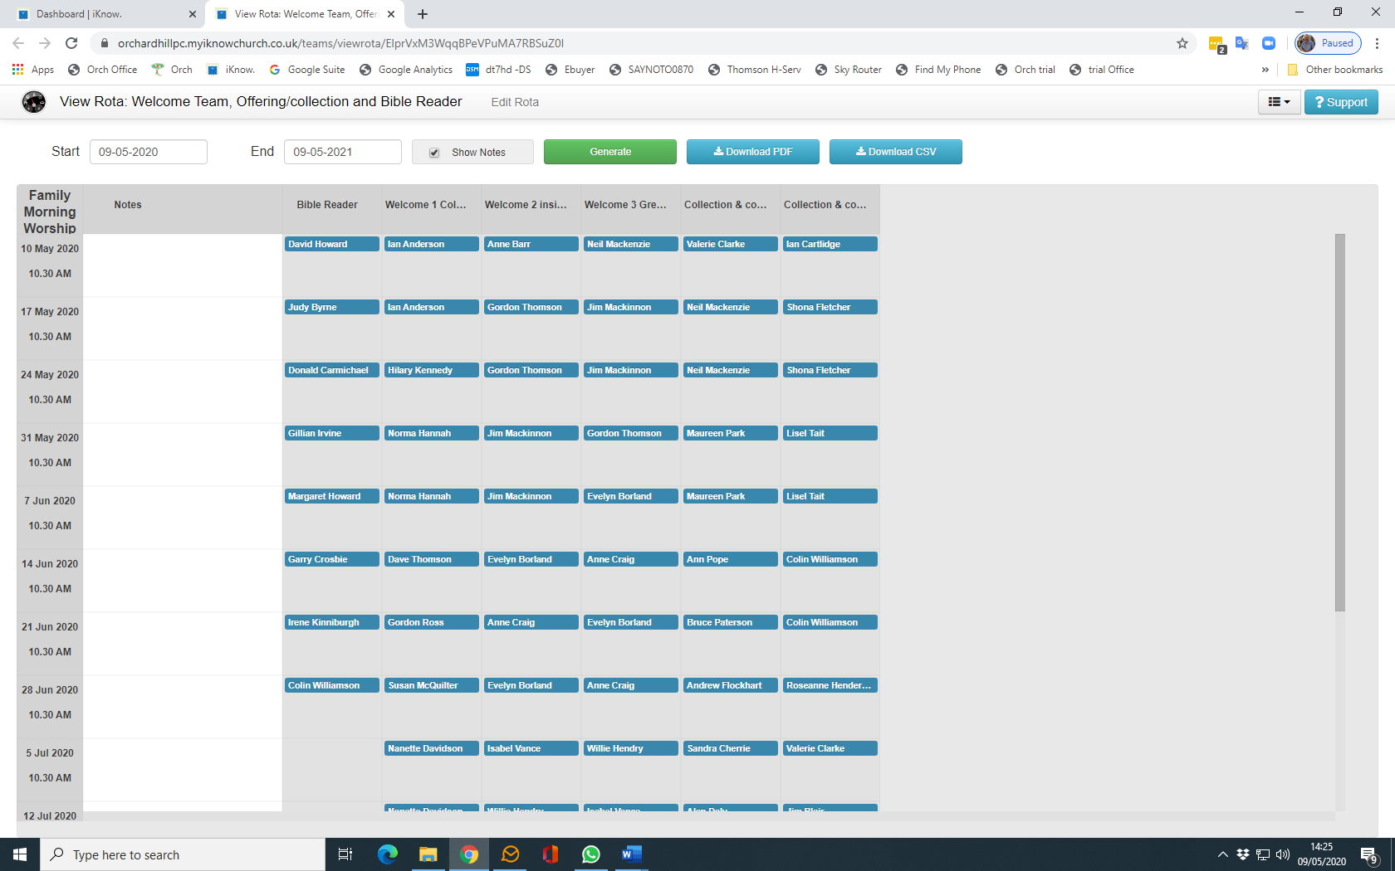
You will see that the Welcome team and the offering duty team along with the bible reader are all on the one Sunday morning Rota.
For Media desk Rotas only.
Media team members will self rota as they did on the old system. Select Teams from the menu bar then select Media desk.
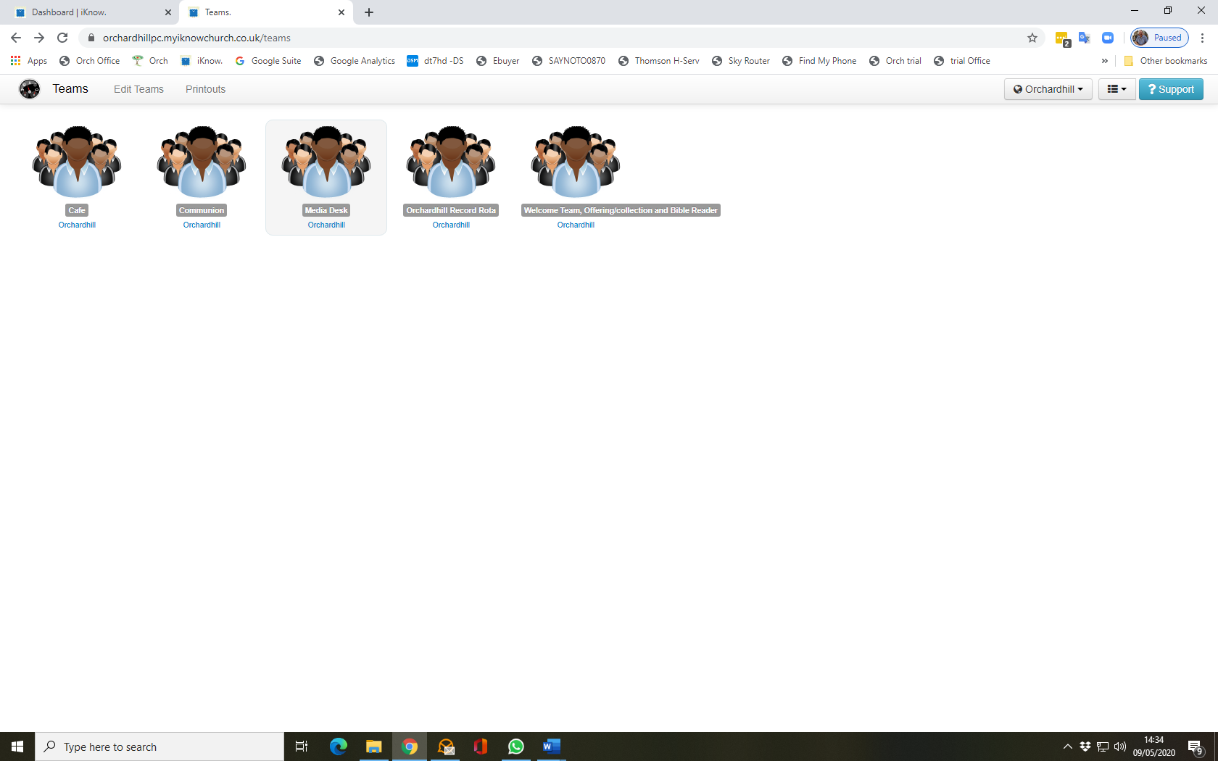
Next select Rotas
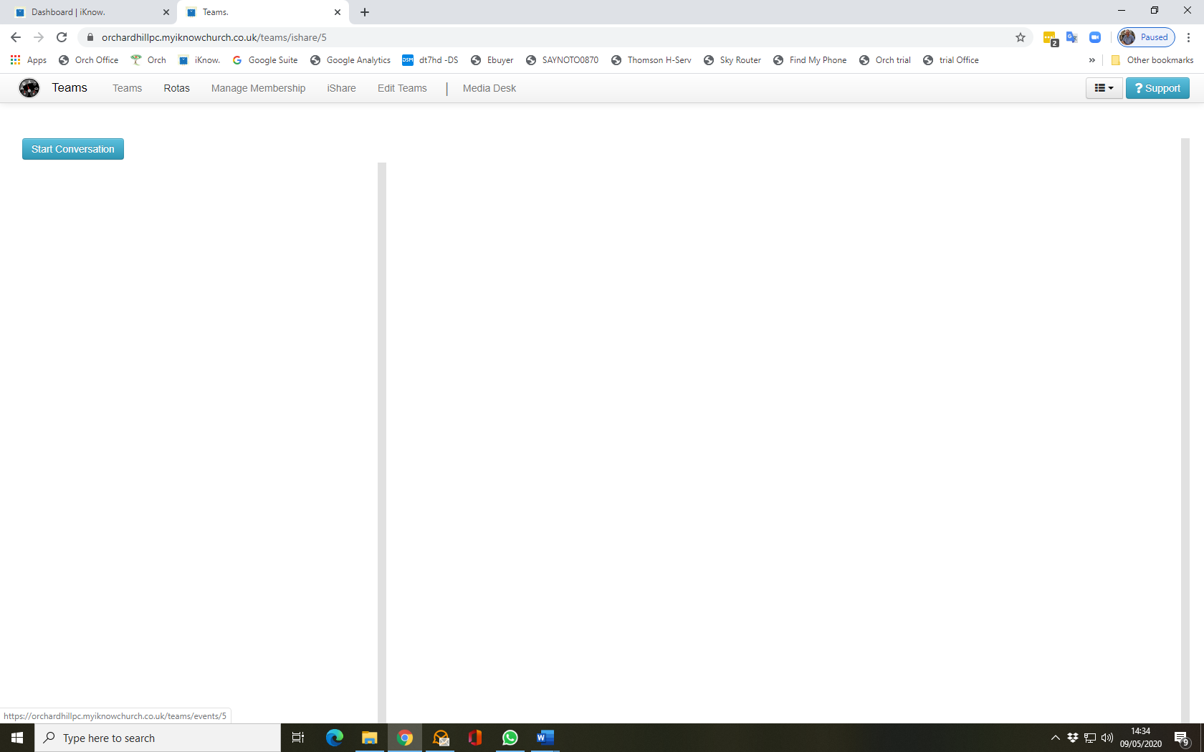

On the Rota page select Family Morning Worship

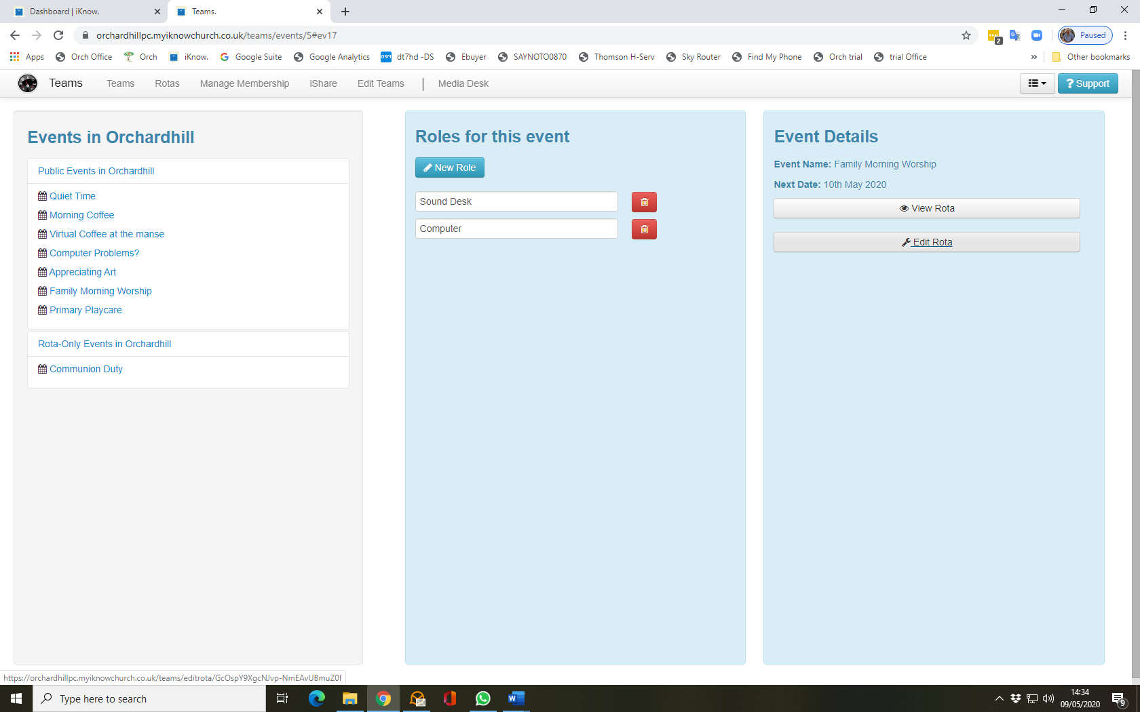
Then select edit Rota
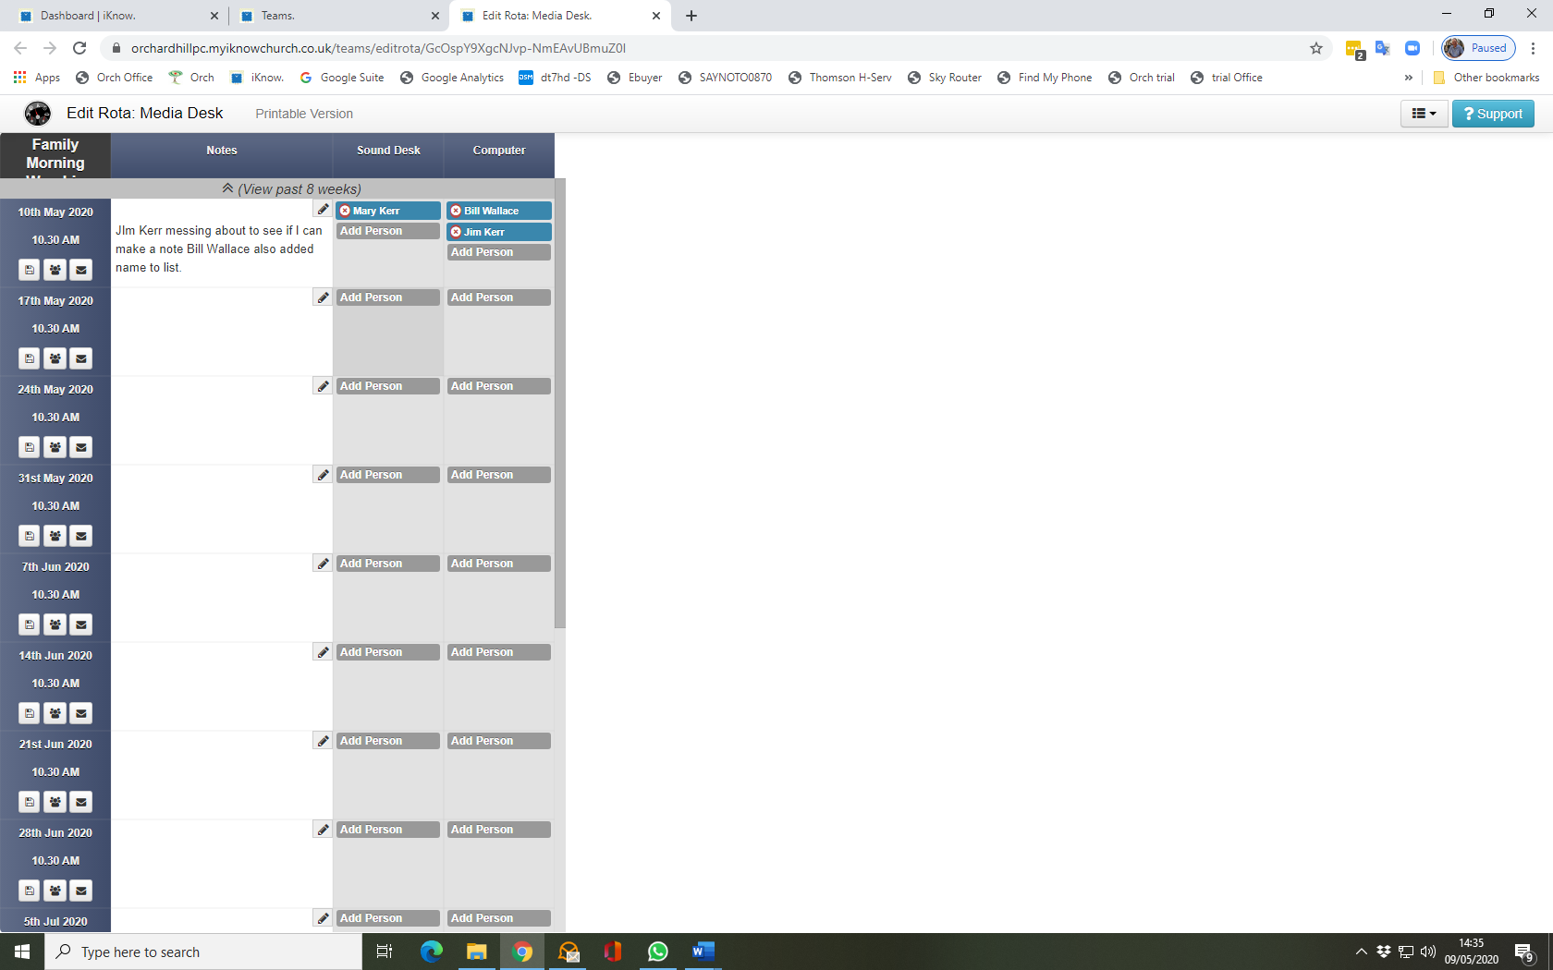
Choose the rota to add your name to, N.B. only one name should be added to each of the roles per week One for sound one for computer.
Select your name from the drop down list of names. If your name is not there then please contact Bill Wallace
