08
Fall
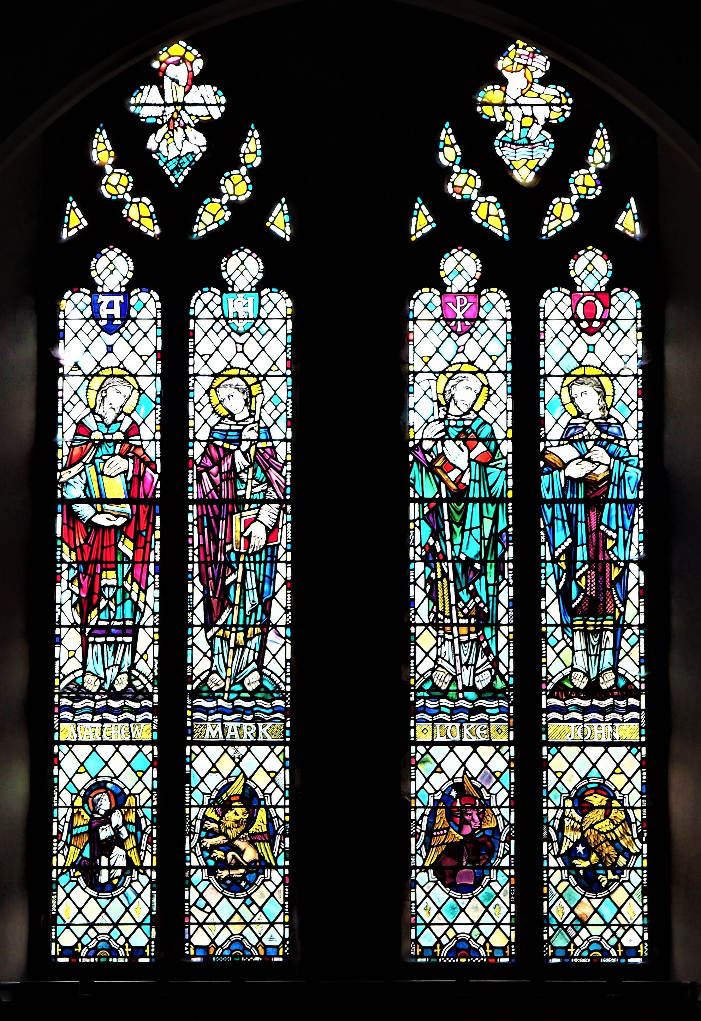 | THE  RECORD  

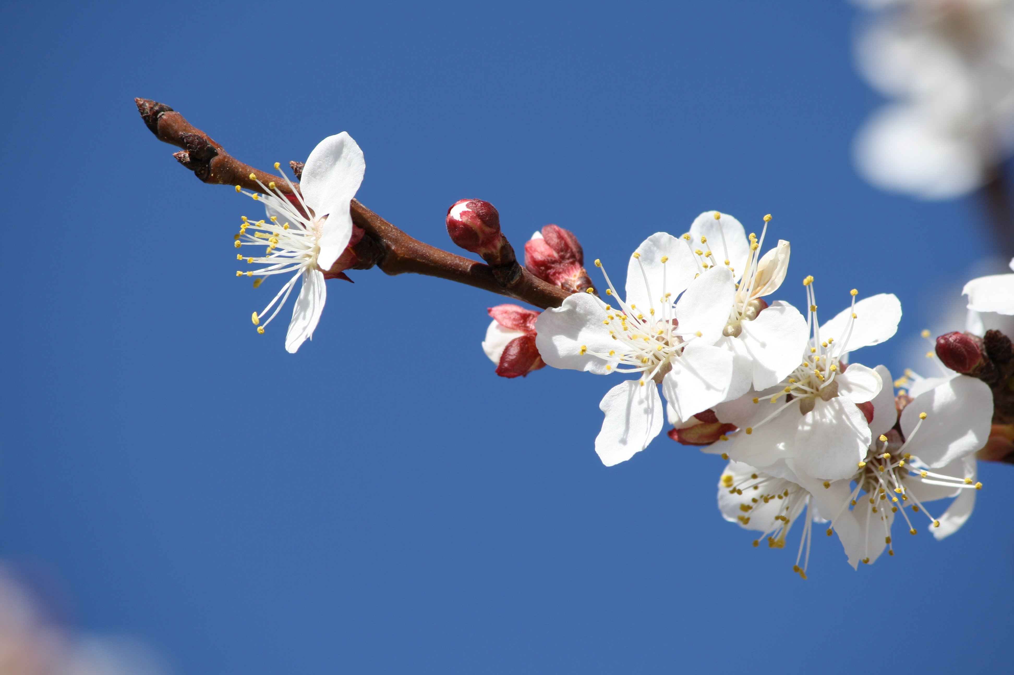
March

2020

A Word from your Minister

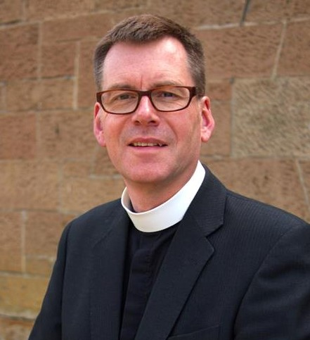

Backwards and inward-looking.

You read this not long after the beginning of Lent, a season which does not have the prominence in our expression of Christian faith it enjoys in others, but nevertheless offers us a useful space. It is a time to be backwards and inward-looking.

It is a traditional time for it focuses on Jesus’ period of solitude in the desert. That, too, harks back to the wanderings of the Hebrew people generations before Christ. It’s interesting that each of his responses to the temptations comes from the same section in the book of Leviticus, a work set in the time God’s people spent in the desert. History and tradition become very present to Jesus.

Jesus’ example suggests we can learn from the past; indeed we must, if we are not to make the same mistakes as before. Looking backwards has its uses, though it is not the only direction in which we gaze (otherwise lamp-posts would be such a risk to health). There is some wisdom in taking time this Lent to reflect on your past journey through life, to recall some significant encounters, remarkable people, opportunities and challenges taken and met, or not. We may be able the better to look forward if we have, to some extent, first looked back.

Lent is a traditional time for introspection, too; Jesus leads us here as well as he spends time away from distractions and focuses on prayer and devotion. He becomes ready for a ministry of apparently endless giving through attending to his self-care, waiting on God, knowing that he is loved and given a task in which he will please the God who cares for him in profound ways.

Many people find value in looking inwards, reflecting on what makes them tick (for that’s often what powers our talk, and our walk). Doing that, consciously aware of the presence of God, can be liberating and energising. Jesus regularly repeated the exercise, though for much shorter periods, finding in the practice a resource to keep going in faith as he depended on God.

Perhaps being backward and inward-looking isn’t as negative as it sounds. It might be one of the things which drive us to be forward-thinking and outward-looking, just as Jesus was. Might some remembering and internal reflection be good for your soul in these weeks?

Your Minister
Grant Barclay.

On the Cover

The four Evangelists
Among our beautiful stained glass windows

Isaiah 58 6-7

6 “Is not this the kind of fasting I have chosen: to loose the chains of injustice and untie the cords of the yoke, to set the oppressed free and break every yoke?
7 Is it not to share your food with the hungry and to provide the poor wanderer with shelter— when you see the naked, to clothe them, and not to turn away from your own flesh and blood?

Let us be grateful to people who make us happy, they are the charming gardeners who make our souls blossom.
Marcel Proust

The Guild

We have three meetings in March, and some alterations to the printed syllabus.

On Monday 9th March at 2pm in the Fellowship Room, we are looking forward to hearing from Mr Iain Lowdon, elder in Carmunock Church, who will tell us about his research into local history with a talk on Castlemilk House and the Stirling-Stuart family.

We are very pleased that Marion Macdonald from Mearns Kirk will be joining us on Monday 23rd March at 2pm in the Fellowship Room to give her talk on "Beadle - Undertaker - Celebrant". This talk has been rescheduled after bad weather caused it to be postponed in January.

We are also looking forward to welcoming Rev. Rebecca Haldane on Monday 30th March at 2pm in the Fellowship Room to tell us about her work as a chaplain for the Sailors' Society in Greenock. The National Guild has chosen to support the Sailors' Society in its wide-ranging work as one of its 6 Guild Projects for 2019-2022.

Everyone is most welcome to join us for these talks.

Reading the Bible in a year.
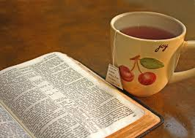
In 2019 a number of our congregation undertook to Read the Bible in a Year. Over the coming months each of the readers will write a short article about their experiences and their thoughts post reading.

The Bible is a big collection of books - 39 in the Old Testament and 27 in the New - and few of us have had the time or even the inclination to read the whole collection, having perhaps been put off by negative comments about the less visited parts, particularly of the Old Testament.
A request to our Minister in late 2018 prompted him to generate a programme for reading the Bible in narrative order, over the course of last year, with 5 days of readings each week, and the weekend to catch up when we fell behind. Each day required reading 2-4 chapters from the O.T. and one from the N.T., with an added Psalm thrice per week, and, quite remarkably, 6 individuals started and stayed the course, getting together for mutual support and discussion every 7-8 weeks.
The weekend "off" proved a master stroke, especially through the more repetitive chapters in Old Testament, and feedback suggested that there were certain books that would not quickly be revisited, but pearls of wisdom and spiritual insight were found sometimes in less expected places, and the consensus, on completion, has been that the exercise was well worthwhile. Special value, in particular, is found in greatly enhanced appreciation of the degree to which nearly all of the New Testament has a background in the Old.
We anticipate that in-depth study of selected books, and/or study of selected passages within books of the Bible, will remain the mainstay of personal and group progress in discipleship, but efforts are being made to obtain copies of shortened condensed versions of the Bible, for use in Orchardhill, from U.K., U.S.A. and New Zealand. The last-named source blends the synoptic gospels of Matthew, Mark and Luke into one, and from perusal online, it suggests an easier but just as fruitful read for those who lack the time to get through the whole Bible.
As suggested last month, we ask that any interested member or adherent should speak to the Minister.

What Is Orchardhill Doing With ERGC?
There is a steady stream of people, in less fortunate circumstances than us, who need our help. Please help by making a contribution in an ERGC envelope and placing it in the Sunday offering (or hand in to the Church Office). Orchardhill's help is appreciated by those in need.
Orchardhill has contributed:
For more information on ERGC please visit their website:
ergoodcauses.co.uk

£97.50 towards the cost of a new washing machine.
£125 towards the cost of a video magnifier.
£291 towards the cost of floor repairs.
£167.50 towards the cost of flooring.
£250 towards the cost of a “trike”.
£100 towards the cost of a cooker.

Soundwaves Show March 2020

Twenty five young children have been working very hard since the beginning of January rehearsing for this year’s show “Joseph and the Amazing Technicolor ® Dreamcoat,” and they need an audience. So, get your tickets soon as we hope it will be a sell-out and come and enjoy the show.

Tickets will also be available to buy before and after Sunday service over the next few weeks – reserve yours now to avoid disappointment.

Life and Work
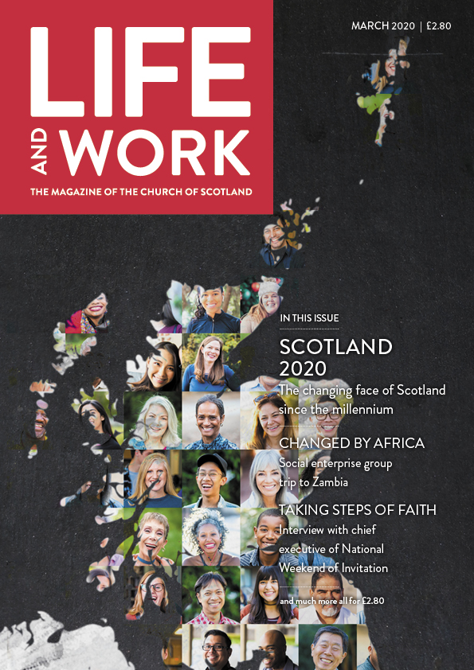
Inside This Month

SCOTLAND 2020
The changing face of Scotland since the millennium
CHANGED BY AFRICA
Social enterprise group trip to Zambia
TAKING STEPS OF FAITH
Interview with chief executive of National Weekend of Invitation
....plus much more packed across 60 page

86th Glasgow Boys’ Brigade Company
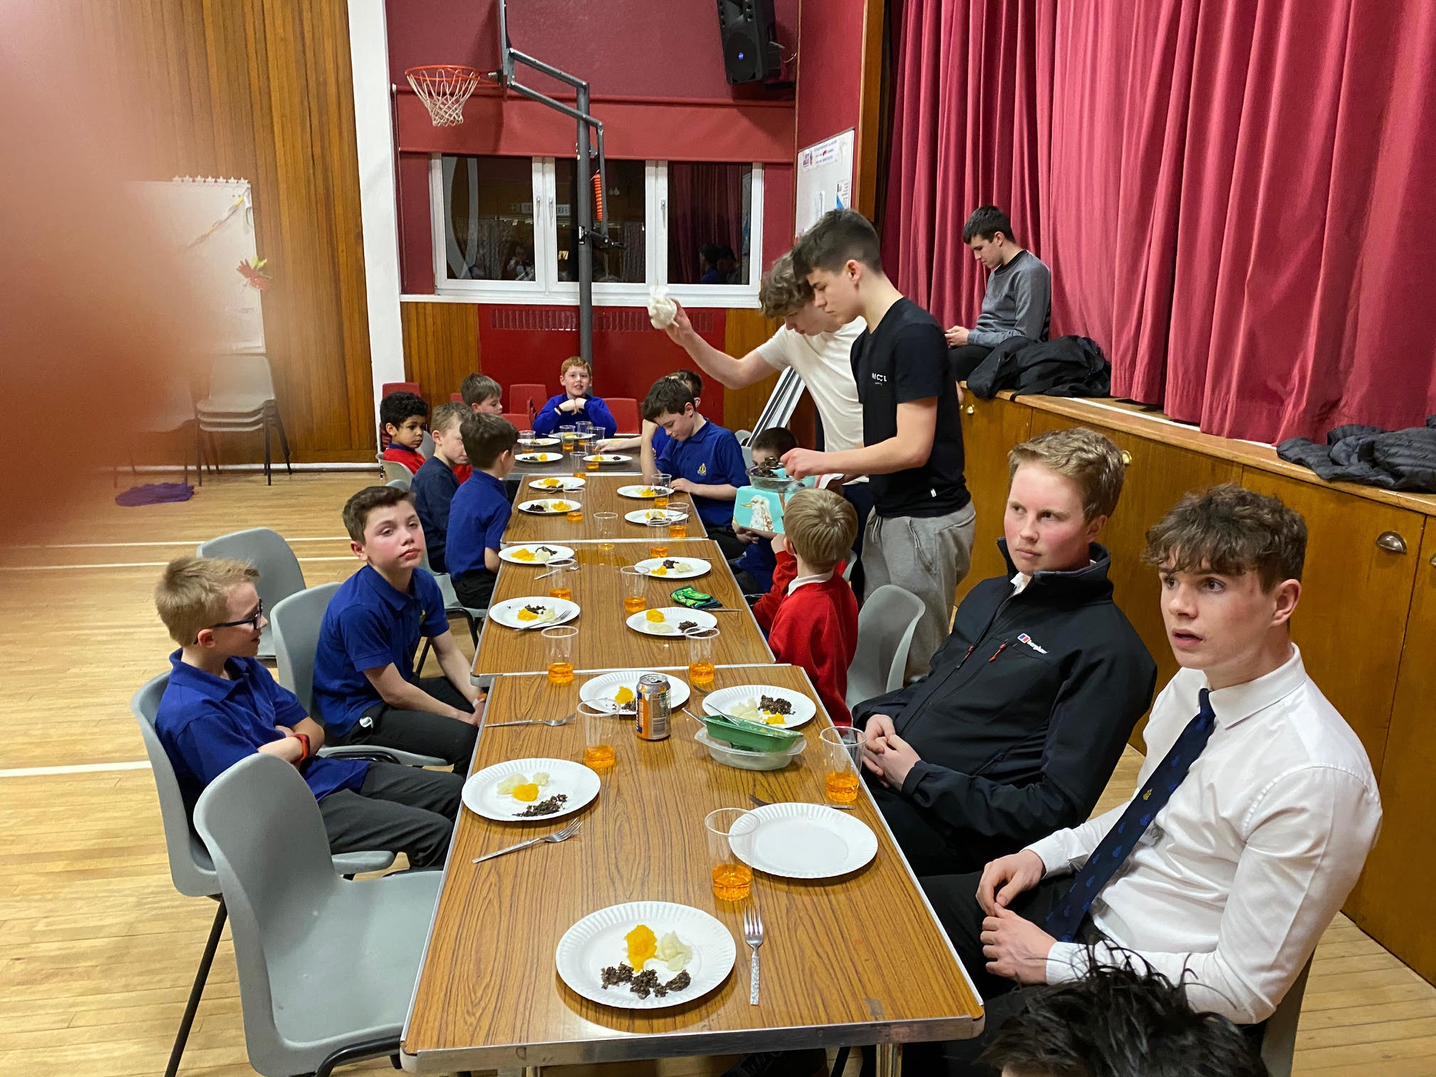
- Session 2019 / 2020 has been a busy year for all sections.

Anchor Boys
All 6 boys entered the Glasgow Battalion Colouring-in Competition and while not coming in the finals 3 boys gained a Bronze Certificate and 3 boys gained a Silver Certificate. There were a high number of entries.
All the boys are working hard to earn their Badges. Under the new scheme the Anchor Boys have to complete 20 achievements to gain their Badge as well gaining their Membership Badge.
In the pipeline there is an Easter Colouring-in competition plus all their various achievements.

Junior Section
Our 12 boys (now 13) have been busy with their achievements – 1st year have to gain 20 achievements as well as their Membership Badge while 2nd and 3rd year have to gain 28 achievements. A tall order.
In January of this year we had 7 boys taking park in the Glasgow Battalion Sports at the Emirates. A total of 192 boys (the largest number yet) took part. The 86th equipped themselves well with all boys gaining at least one medal.
Three boys went for the Battalion Ten Pin Bowling Event at the Quay. This was a fun morning and they all really enjoyed themselves, getting 2 games for £3.00. Not a bad morning.
The next thing in the pipeline is the ‘Kip on the Glenlee’ at the beginning of March.
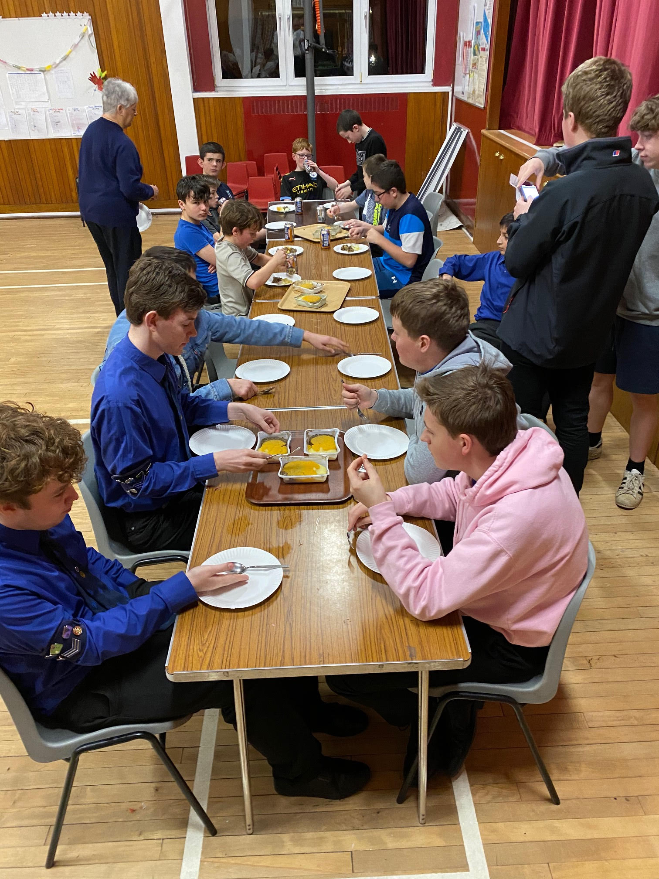

Otherwise it is just keeping up to date with their achievements.

Both Sections enjoyed their night learning about Robert Burns with a Simple meal of haggis, neeps and tatties. The Selkirk grace was said and part of the Address to the Haggis. They also enjoyed an evening of Connect 4, Ten Pin Bowling and Simple Table Tennis

Company Section
We have 7 Boys involved in the Discover Program which has 3 zones to cover. Each zone requires 21 areas are covered in each of Community, Recreation and Skills.
Boys are challenged to achieve this in each of the 3 years before starting on the 4th year when they undertake course work and voluntary work in relation to their quest to obtain The President’s Badge. Each year the badge work required more thought and effort.

We had 3 Boys attending the Building Your Skills (President’s Badge) Course at Greenbank Church on Saturday 16/02/2020 1.30 to 5.30pm
Once completed they can be nominated for the Queen’s Badge Course to start in September over the next 2 years.

We have one Boy in his first year of the Queen’s Badge Course who attended the Skills a For Queen’s Badge Course on Saturday 09/02/2020.

Five Boys have submitted their books which record at least 30 hours volunteering within the Brigade or Church, together with at least 30 hours volunteering out with the Company. In addition they have had to demonstrate that they have undertaken a sport in which they had little skill and through application be judged to have markedly improved in that sport. They also have to nominate a skill that they wish to improve and again this is measured by the improvement. Having completed the above the Boys will use these experiences together with what was learned on the Skills for Queen’s Badge course they were on last year at the beginning of their course when they attend a Queen’s Badge Residential Course at Auchengillan Outdoor Centre 27-29 March 2020. This course tests the abilities of the Boys in many areas. Once through this Course they can be nominated to receive the highest award in the Boys’ Brigade, The Queen’s Badge which will be presented to the recipients at the Glashow City Chambers on 28/05/2020.

We wish our Queen’s Men every success in this course and all other Boys we wish them well in the Badge work that they are undertaking.
Stephen Bennett & Margaret Howard

THINKING ALLOWED – 12th March 2020

Dame Cicely Saunders and care of the dying
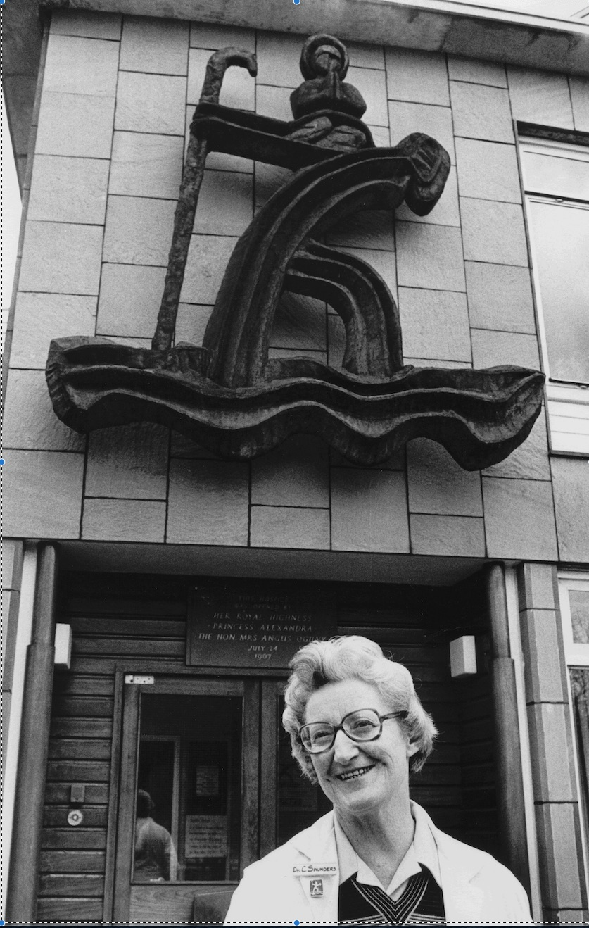
Known as ‘the woman who changed the face of death’, Cicely Saunders had a remarkable life. She trained in nursing, social work and medicine, fell in love with three Polish men, and founded the world’s first modern hospice. Inspired by a Christian faith that deepened as she grew older, she initiated a global movement to transform the care of the dying in ways that remain highly relevant today.

The Speaker : Professor David Clark
A Professor of Medical Sociology at the University of Glasgow, Dumfries Campus, David Clark is the author of a biography of Cicely Saunders that was published in 2018, to mark the centenary of her birth – Cicely Saunders: A life and legacy. Oxford University Press.

Sunflower Growing Competition for Adults and Children

Thank you very much to everybody who has helped to prepare the sunflower seed envelopes for the growing competition.
Seed packets priced £1 will be available for purchase during March on Sundays, and from the Church office and café. Please make sure that you buy packets for yourself, friends, family, neighbours, and work colleagues. People can take part all over the world, sending in their photos and videos to the website, but only those living within a 2.5 mile radius of the church can have their sunflower measured for the competition.
Thanks also to everyone working quietly in the background preparing for the various parts of the Sunflower Spectacular.

Sunflower Installation around the Church and Memorial Halls
Those who have already indicated their willingness to help with the growing of sunflowers for the installation, should meet in the Church Hall after the service on Sunday March 8. Extra helpers would be made most welcome.
Anyone with available greenhouse space for small sunflower plants, should please get in touch.
A rota is being prepared for the aftercare of the plants once they are in situ. This is an essential part of the project, and, if you are able to help in this way, and have not already done so, please make contact with Alexis Wallace. Tel. 0141 585 7986 Email: alexis.wallace53@gmail.com
Anyone with Comfrey in their garden, or who knows of a local source, please get in touch, as it will be required to make liquid feed.
Please remember that the sunflower Donation Box is out each Sunday, and that any Donations will be used to defray expenses. Thanks very much

Spend a few pennies - Twin your toilet!
We take toilets for granted. We all have one......or two......or possibly three .....or even four in our houses. In our church we have ladies toilets, gents toilets and a disabled toilet. If you have used these facilities recently, you may have noticed a picture of a toilet block - one in Malawi and one in Bangladesh. These have been provided by a donation from the Orchard Community Cafe. Did you know..... 2 billion people don’t have a safe, hygienic loo. A child dies every 2minutes from a sanitation related illness. Teenage girls drop out of school because there is no decent toilet. Women are attacked or bitten by snakes if they go out to relieve themselves in the bush, often late at night. The money is not just used to build toilets. People are also taught the importance of good hygiene and sanitation. (Facts and figures provided by Tearfund) A toilet block costs £240. For £60 you can twin your own toilet. Already several of our members have twinned their toilets! For more information go to toilettwinning.org and help flush away poverty!
- Congregational Register

- Disjunction: Ian and Patricia Brown

Deaths: Josie Cameron on 8th February 20209
- Well done thou good and faithful servant. Rest safe in the Lord

Who’s Who in the Church
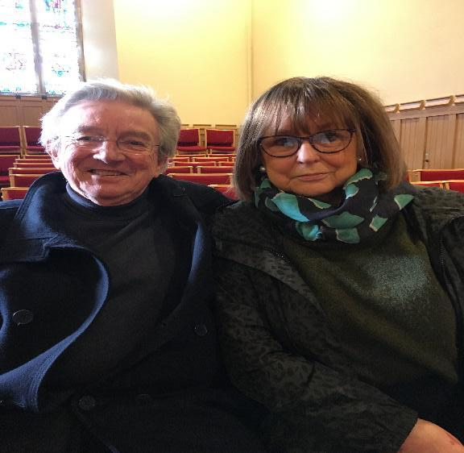
Alan (surveyor) and Sandra Daly.
When Alan and Sandra moved to Giffnock one of their main goals was to find a Church where they would be welcomed and feel at home. They tried a few churches and when they came to Orchardhill they were made so welcome that they decided to join our congregation. One and half years later they are still enjoying coming along and helping within the church.
Alan’s skills have been put to good use within the property committee. We are glad to have you with us.

Deadline for April’s Orchardhill Record
Sunday 15th March 2020 is the deadline for the April 2020 edition of the Orchardhill Record.
Contributions should be sent by email to Record-Team@Orchardhill.org.uk before 1.00pm or left in the relevant slot in the rack in the church corridor no later than 10.30am. Using that email address ensures that every contribution goes to the editorial team not just the editor.
We prefer contributions to be sent by email, and we cannot accept any handwritten or typed item that does not identify the source. Nor can we accept pdf files. A photograph or logo must not be embedded in the article. Please send images and inserts as separate attachments to allow flexibility in laying out pages.
You are required to ensure anyone featured in your article(s) has given consent to be identified either for the specific article, club, group or more generally for Orchardhill Record.
The editor acknowledges every contribution. Contact them before the deadline if you have not received confirmation of your contribution.

Welcomers

 | Entrance | Sanctuary | Greeters/Ushers

MARCH
1 | May Liddle | Irene Kinniburgh | Irene Kinniburgh
8 | Irene Kinniburgh | Irene Kinniburgh | May Liddle
15 | May Liddle | Jim Kerr | Jo Weir
22 | Jo Weir | Jim Kerr | May Liddle
29 | Marion Watson | Fiona Thomson | Jo Weir

APRIL
5 | Jo Weir | Fiona Thomson | Marion Watson
12 | Marion Watson | Alex Mall | Anne Barr
19 | Anne Barr | Alex Mall | Marion Watson
26 | Neil MacKenzie | David Howard | Anne Barr

Offering Teams
MARCH
1 | Irene Kinniburgh | David Evans |  | Nanette Davidson
8 | Irene Kinniburgh | David Evans |  | Joyce Winning
15 | Jim Kerr | Fiona Coupar |  | Joyce Winning
22 | Jim Kerr | Fiona Coupar |  | Norma Hannah
29 | Fiona Thomson | Margaret Howard |  | Susan McQuilter

APRIL
5 | Fiona Thomson | Margaret Howard |  | Susan McQuilter
12 | Alex Mall | Peter Worthington |  | Ann Pope
19 | Alex Mall | Peter Worthington |  | Ann Pope
26 | David Howard | Norma Hannah |  | Roseanne Henderson

Scripture Readers
MARCH |  | APRIL
1 | Dave Thomson | 5 | Anne Anderson
8 | Marion Simpson | 12 | Lindsay Barr
15 | Ian Anderson | 19 | Shona Fisher
22 | Angela Peacock | 26 | Ian Cartlidge
29 | George Robertson


QUIZ – Series 2

The Gospel of Luke in Chapter 24 tells us that two disciples were going to a village called Emmaus when Jesus appeared and walked with them.
Many "Old Master" artists have painted works with the title "The Supper at Emmaus".
For the purposes of this quiz four artists have been chosen all of whom were born after the year 1500.
The answer to each question comprises two parts: the name of the artist and his date of birth.
Questions:

1). The date of birth of this artist is a prime number.
2). The year of birth of this artist is the prime factorisation of three numbers.
3). The year of his birth comprises seven factors only two of which are prime numbers.
(HINT - A to the power 3 times B. where B is larger than A)
4). This artist was made insolvent in 1656.
As before one point for each question and a bonus of one point if all the question are answered correctly.
This is the first quiz in Series 2; the same rules apply. It is open to all aged 18 years and under. Anyone
achieving a score of 25 points for the whole series will receive a book token valued £30.
The winner of Series 1 is Cameron Griffiths who receives a book token of £30.

March Into Springtime....With A Laugh!
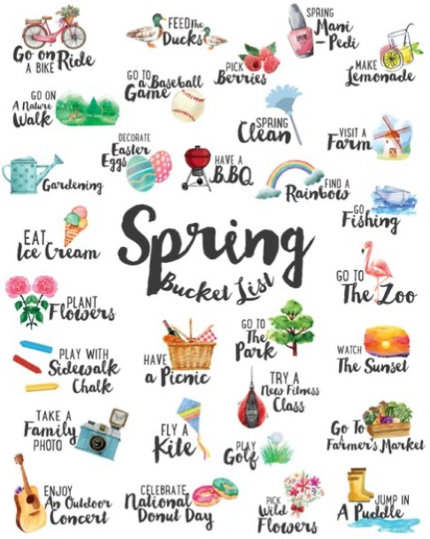
Today, my son asked "Can I have a book mark?" and I burst into tears.
11 years old and he still doesn't know my name is Brian.

If a child refuses to sleep during nap time, are they guilty of resisting a rest?

The secret service isn't allowed to yell "Get down!" anymore when the
president is about to be attacked. Now they have to yell "Donald, duck!"

I'm reading a book about anti-gravity. It's impossible to put down!

My friend keeps saying "cheer up man it could be worse, you could be
stuck underground in a hole full of water." I know he means well.

If you see a robbery at an Apple Store does that make you an iWitness?

Orchardhill Calendar

March
Sunday | 1 | 10.30am | Family Worship | Rev Grant Barclay
Sunday | 8 | 10.30am | Sacrament of the Lord’s Supper | Rev Grant Barclay
Thursday | 12 | 7.30pm | Thinking Allowed | Professor David Clark
Sunday | 15 | 10.30am | Family Worship | Rev Grant Barclay
Sunday | 15 | 7.30pm | Church Quiz
Sunday | 22 | 10.30am | Family Worship with Stated Annual Meeting | Rev Grant Barclay
Friday | 27 | 7.30pm | Soundwaves Show
Saturday | 28 | 7.30pm | Soundwaves Show
Sunday | 29 | 10.30am | Family Worship | Rev Nigel Chikanya
Tuesday | 31 | 7.30pm | Congregational Board
April
Sunday | 5 | 10.30am | Family Worship | Rev Grant Barclay

Orchardhill Parish Church, Church Road, Giffnock Glasgow G46 6JR
phone 0141 638 3604
website: www.orchardhill.org.uk
email: secretary@orchardhill.org.uk

Orchardhill Parish Church: Scottish Charity number SC 009774

